Exercises:

1. The term "neorealism" describes the life of regular, ordinary people in a realistic environment. Submit collage or photo / video footage created about this topic by you.
2. Create (manually or graphically) a poster of "Magdana's Donkey".
3. How would you entitle this photo?
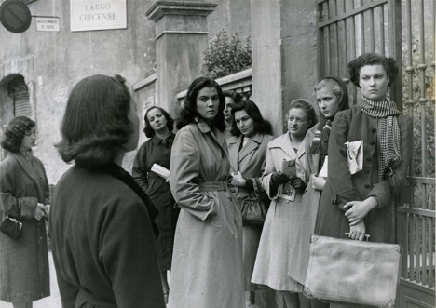

4. “Kuleshov’s Effect” is the combination of two different, unconnected, independent frames in a way, that it acquires a new meaning. Describe and entitle a pair of shots according to this example:
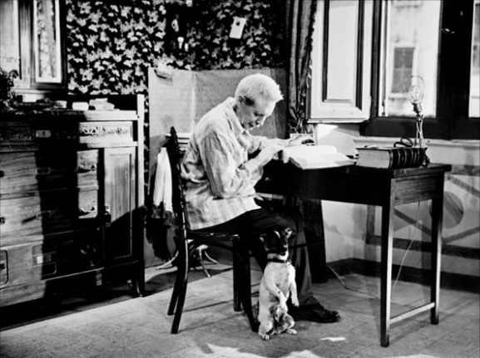
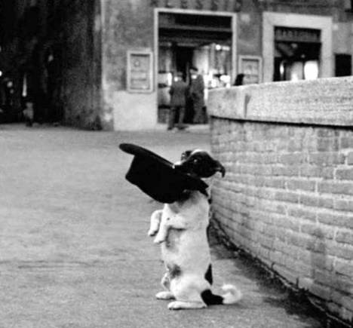

+ =
Footage from the film “Umberto D”

5. Since the 1950s natural, everyday conversations and dialogues have been gradually settling in Georgian cinema. How important is it in the artwork for the characters to speak as a real people do in life?

6. What do you think: the social issues or problems reflected in artwork lead to a positive or to a negative outcome in society? Write an essay (150-200 words).

